**XMS Smoke Test Guide**

XMS-STS is a java application that will execute a series of basic XMS use cases to validate Powermedia XMS installation and configuration independently of the user’s application.

Currently there are 7 use cases. These have to be executed manually by selecting and adding them to the run list. Each of the test cases generates an audit file consisting details related to the selected test and its status.

**Prerequisites**

* JAVA 1.8

**Obtaining the Project**

To use XMS-STS, download the zip folder from Github

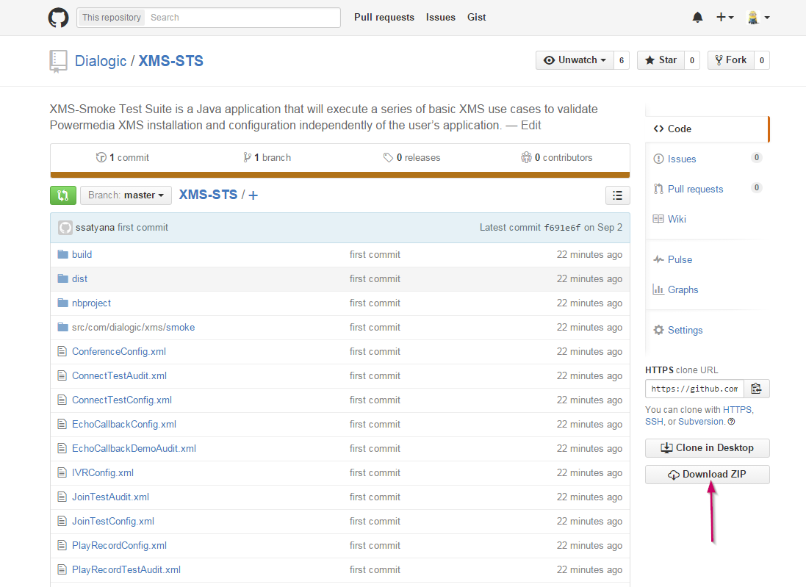

**Design**

XMS-STS consists of the following components/packages

Packages:

* gui – This consists of all the GUI components which allows the user to select the use case to run and set the run configuration for the use case.
* test – This package consists of the main components shared by all the tests.
* examples – Consists of a list of use cases.
* stim – TODO: this will include stimulated test cases.

Components:

* Test Manager – This is the main program that runs the test case in sequential order from the run list.
* Test case – There are 7 test cases: - ConnectTest, EchoCallbackDemo, JoinTest, LoadTest, PlayRecordTest, SimpleConferenceTest, SimpleIVRTest. Each of these test cases will be explained in details in the later sections.
* Controller – GUI which allows the user to select the test cases to be executed. This window also shows the progress and the status of the test cases.
* Configuration – Each test case has a configuration file used to execute the test. This configuration file consists of information like the mode of service, IP address, file name, no. of times to execute etc. This will be explained in detail in later sections
* Audit/Reporting – The execution of each test cases will be recorded in the audit file. Checkpoints are used to track the status of the test case. This file includes the checkpoint information, info messages, configuration details, no. of steps passed/failed, test status (success/failure) etc.

Reporting:

* Audit files generated after the test completion are stored in the auditFile directory under XMS-STS project
* Config details entered by the user is stored in xml format in the config directory under XMS-STS project

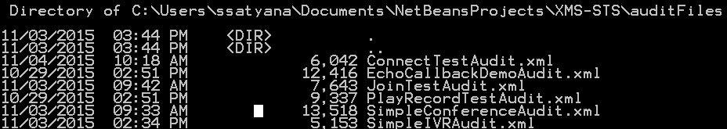

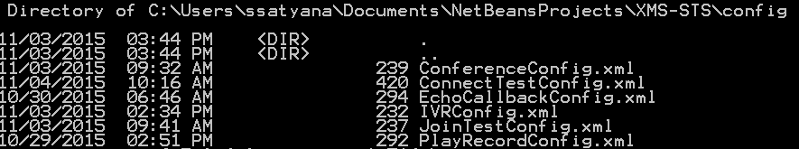

**Procedure**

Unzip the file downloaded from Github and then go to the top level directory where you will see the /dist directory. From the top level directory run the tool as follows:

C:\Users\ssatyana\Desktop\PROJECT-3\DocsPics\CmdPrompt.PNG

Following are the steps to follow to run test case(s). The basic flow is explained using the ConnectTest use case.

1. Running the jar will display the controller window used to select the test case to run.

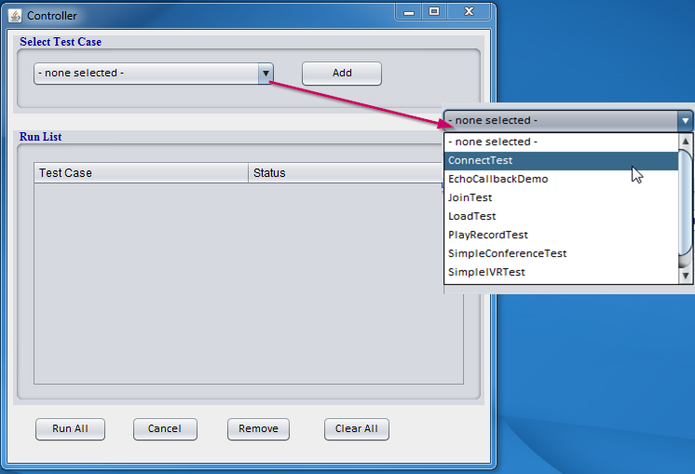

The controller window consists of the following components:

* Drop down menu – Listing of all the test cases
* Add button – After selecting the test case use this button to add to the run list
* Run list table – This is a table showing the Test case name and the status of the test case. The status keeps changing based on the current step of the test case
* Run All button – runs all the test cases in the run list
* Cancel – Closes the window and exits the program
* Remove – Removes a selected test from the run list
* Clear all button – Clears all the selected tests from the run list

1. When a test case is selected (using the Add button) another window pops up. This window is used to set the config details for the selected test case.

*Note*:

* The config fields vary based on the test cases. Additional fields present in all test cases will be explained in the later sections.
* When running the test cases for the first time user has enter the field details. Some of the fields will have placeholders to guide. When running the test for the second time, the fields will be auto-populated from the standard file mentioned in the config file name field. If the user changes the name of this config file, it will still auto-populate from the standard file name.

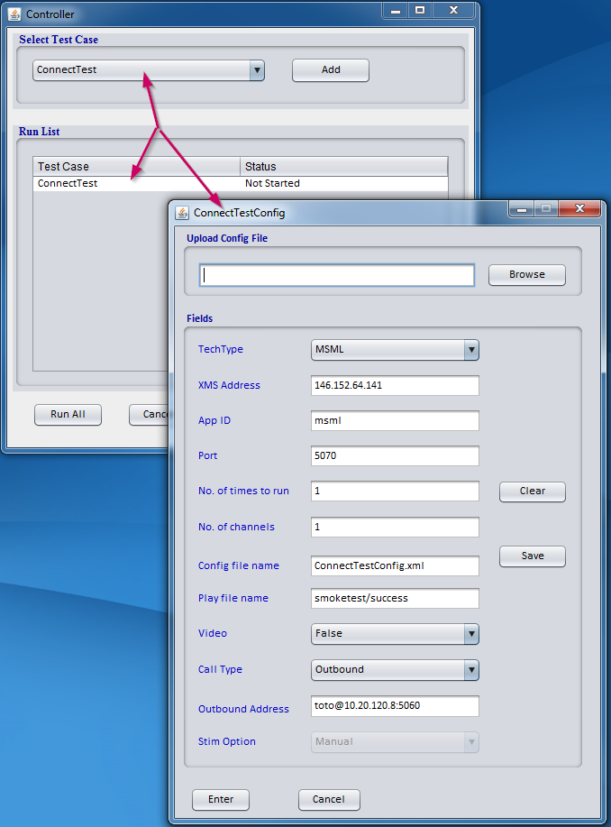

Notice that on selecting the test case a config window pops up and the test is added to the run list.

The following are the components of the config window.

All the test cases will have the following common fields:

* Upload Config File – This is used to allow the user to upload configuration file from the system. The XML document format should match the sample provided at the end of this document.
* Tech Type – This allows the user to select the tech type used to run the selected test case. The two modes are REST and MSML.
* XMS Address – IP address of the XMS
* App ID – This field is auto populated when the
* Port – This field will be enabled only for MSML mode. Used to set the local port used to create the connector. If the user does not select one, default 5070 port will be selected.
* No. of times to run (count) – No. of times to run the selected test
* No. of channels – No. of channels to run the selected test
* Config file name – Standard file name where the entered configuration will be stored
* Stim Option – Manual/Auto. This field is disabled for now as it is not implemented yet. Default is manual

Additional fields: There are additional fields present in all use cases

Connect Test:

* Play file name – file played on connecting to XMS
* Video – Set to true/false. Media type can be set to video or audio only. Default is audio.
* Call Type – Inbound or Outbound call
* Outbound address – Address to call to when the call type is outbound

EchoCallbackDemo and PlayRecordTest:

* Record file name – file used to record
* Max time – Maximum time to record

1. After entering the configuration details press “Enter”. This will take you back to the controller panel. Additional test cases can be selected. All tests will be run sequentially.

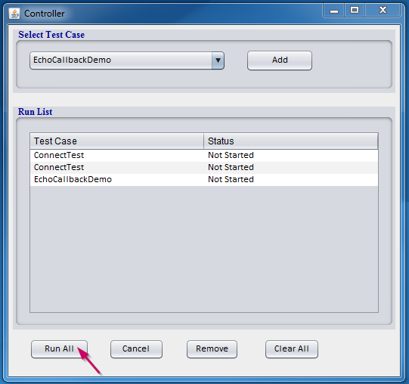

1. On pressing Run All the tests will start executing. As the test progresses, status of the test can be viewed under the “Status” column.

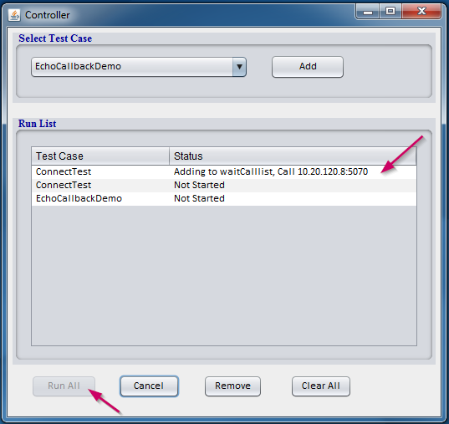

Now use any sip client (eg. Linphone ) to make a call to the application based on the tech type selected. For REST the calling address will be appid@xms_ip_addr and for MSML the calling address will be the local address where the application is running test@local_ip:port. The controller will display the address to call to in the status column.

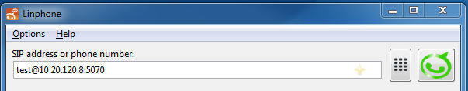

The call flow progress can also be tracked on the console window.

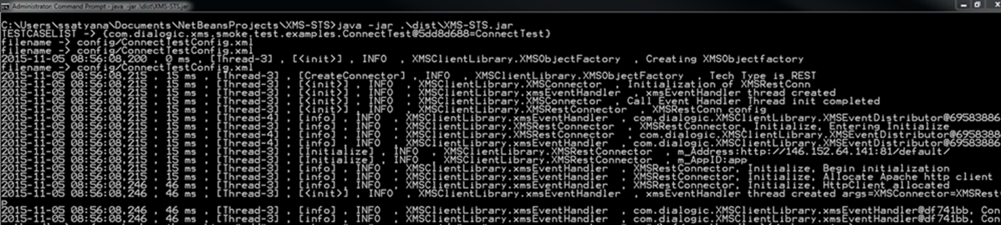

Once the test is completed the status displays if it was a SUCCESS/FAILURE.

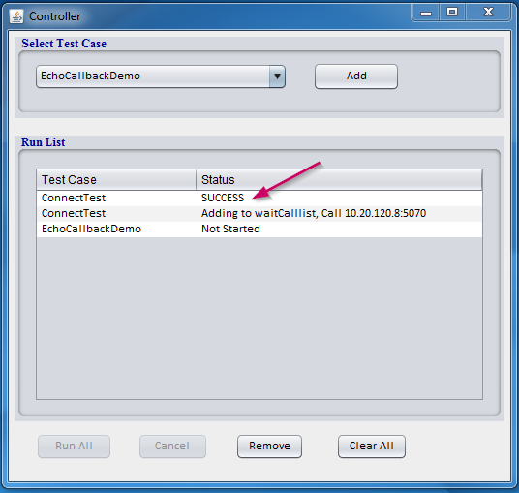

**Test Case flow**

This section describes the flow/steps of each test cases. The web sequence diagram shows an upper level understanding of the messages exchanged. For detailed information about the call connection and XML content, please refer the wireshark provided.

*Note:*

1. *Prompts used in these test cases are present in the media directory in the zip file downloaded from Github. These .wav files were stored under /var/lib/xms/media/en-US/smoketest directory while testing. This path is hard coded in most of the test cases. If the file location is changed, please update the test cases to point to the correct directory.*
2. *Web Sequence diagrams attached in this document will also be placed in the “docs” folder in the XMS-STS zip.*

**ConnectTest**

XMS-STS uses the Client Library to make an inbound or outbound call based on the configuration details entered by the user.

Following are the steps:

* 1. Make call(inbound/outbound)
  2. After the call gets connected, plays a prompt “If you can hear this, you are successfully connected to XMS”
  3. Hang up call

User can use this to make REST inbound/outbound call or MSML inbound/outbound call.

*Inbound REST:*

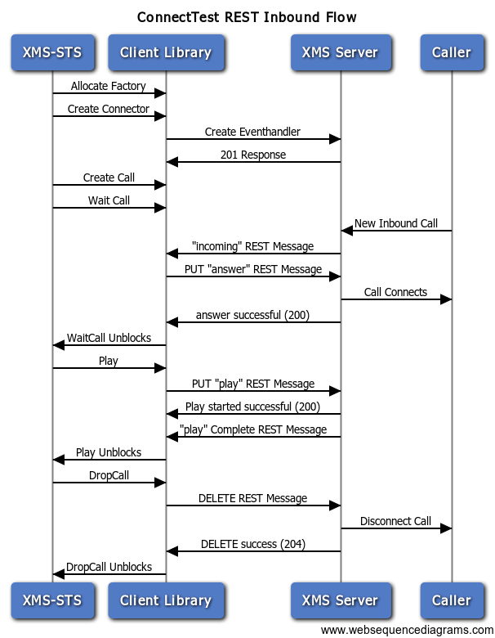

*Inbound MSML:*

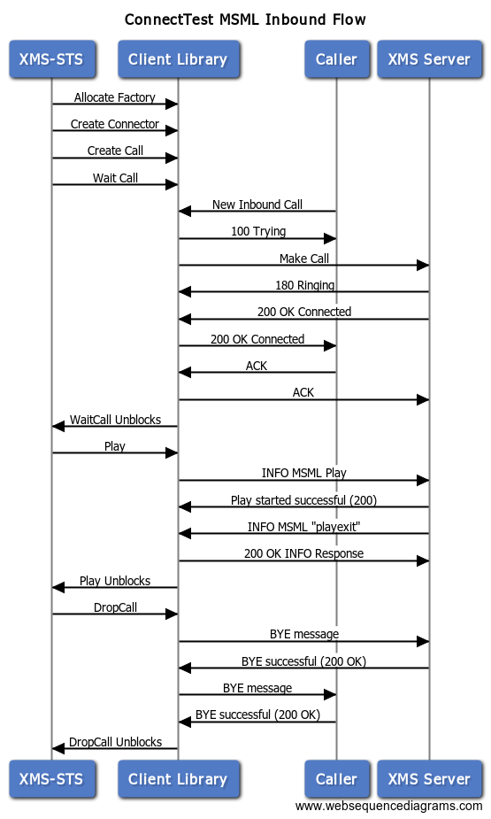

*Outbound REST:*

In the outbound test case, the address to call to should be mentioned in the outbound address field provided in the configuration (see below)

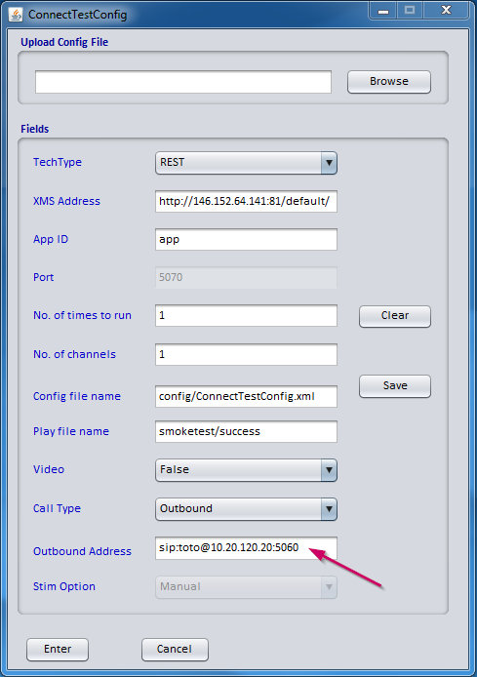

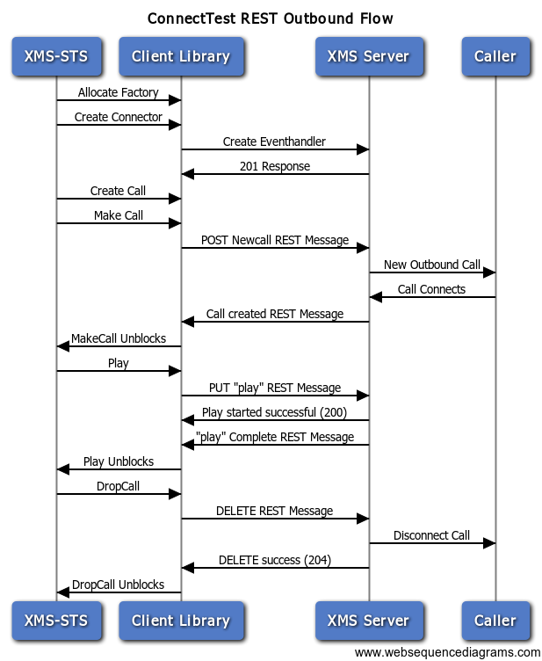

*Outbound MSML:*

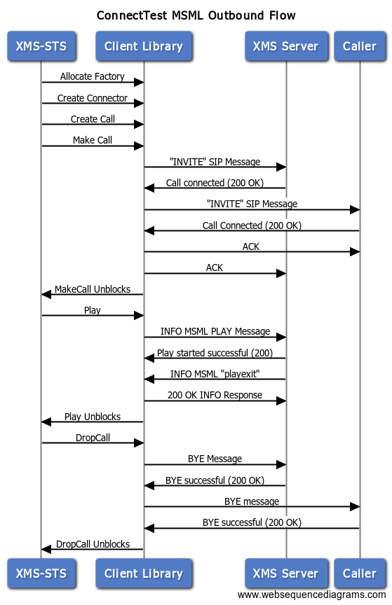

**EchoCallbackDemo**

Steps:

1. Client calls the application(MSML mode) or XMS(REST mode)
2. On connected state, starts recording. Media is recorded for the max time set by the user in the config window, default is 10s.
3. When record is complete, hangs up call
4. Make Outbound call to the same client
5. Playback the recorded file

*REST:*

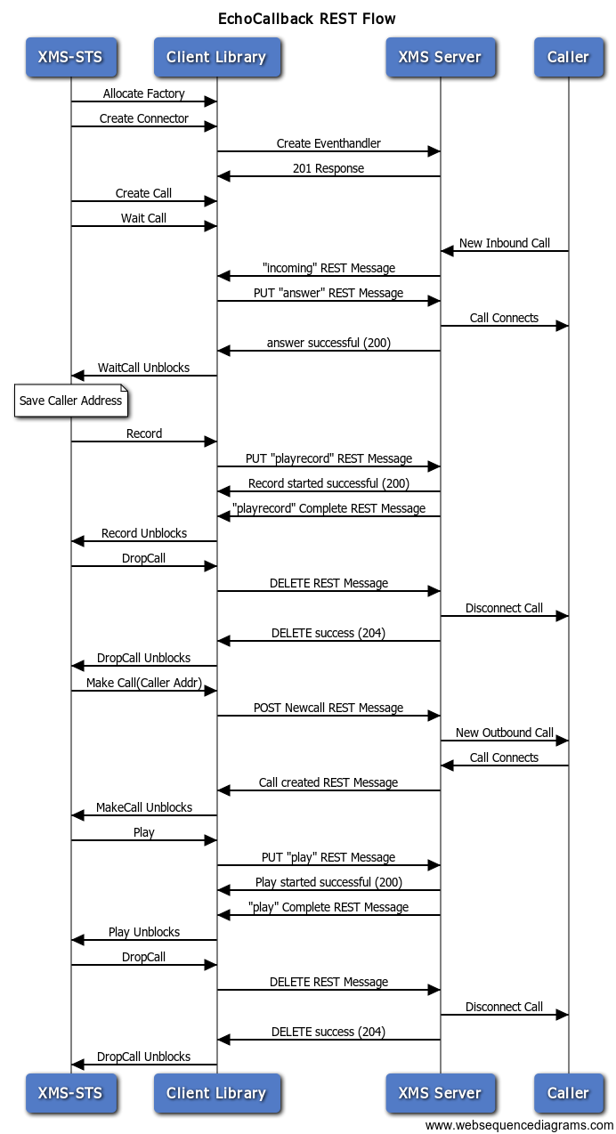

*MSML:*

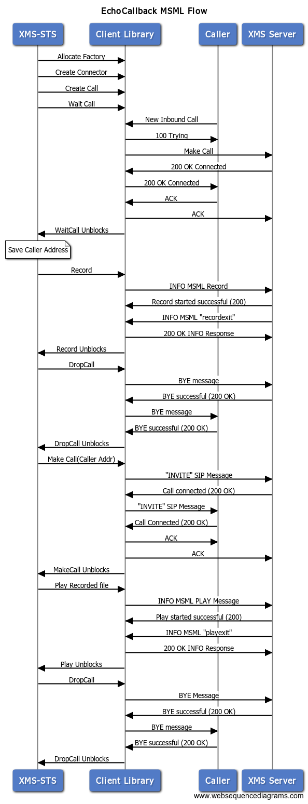

**PlayRecordTest**

This test is similar to EchoCallbackDemo test except there is no call back to the client.

Steps:

1. Client calls into application
2. Record a file – based on the max time in the configuration settings
3. Once recording is done, playback the recorded file
4. Hang up

*REST:*

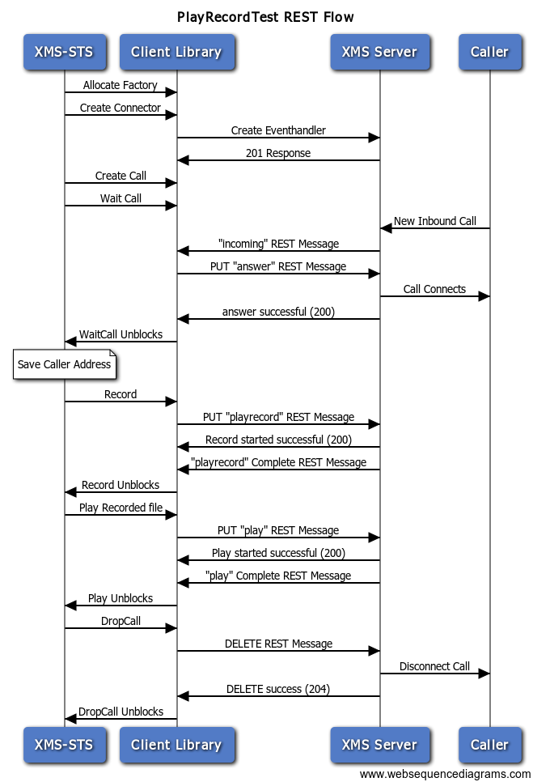

*MSML:*

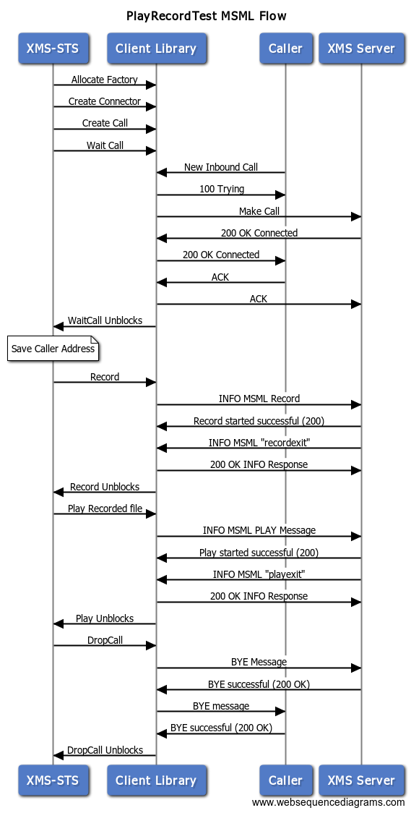

**JoinTest**

This tests the join functionality of XMS.

Steps:

1. Caller A dials into the application
2. Caller A hears basic prompt “Please wait for second caller to join”
3. Caller B dials into the application
4. Caller B hears basic prompt “Now joining with first caller”
5. Join A and B
6. Wait 30s or until one of the callers hang up and terminate calls

*REST:*

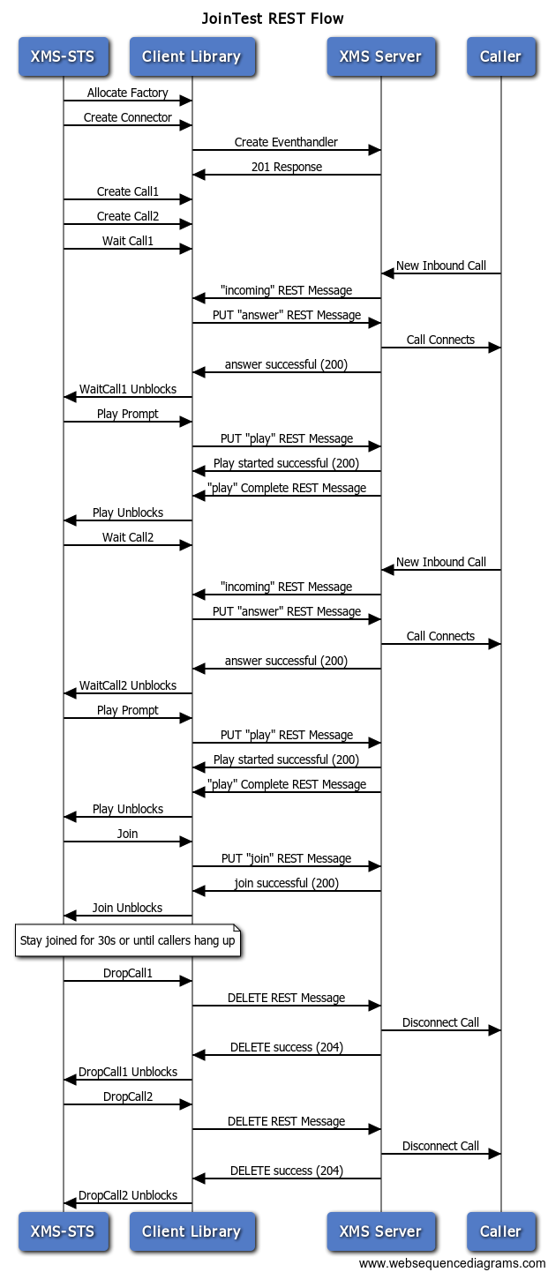

MSML:

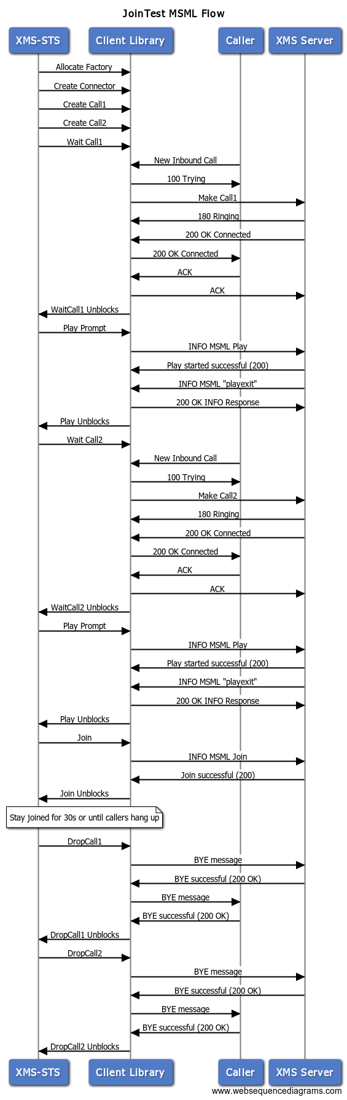

**LoadTest**

Checks load balancing property of XMS. This test runs asynchronously and requires call back functionality to handle the events.

Steps:

1. Place xx calls into the application
2. Play prompt
3. Terminate the calls

**SimpleConferenceTest**

This is a basic 3 party conference.

Steps:

1. Wait for callers
2. On first caller, play prompt "adding to conf" and establish a conference.
3. As additional callers dial in, play prompt "adding to conf" and add to conference
4. As conferees leave, clean up their call leg
5. When the last conferee leaves, clean up call leg and delete the conference.

*REST:*

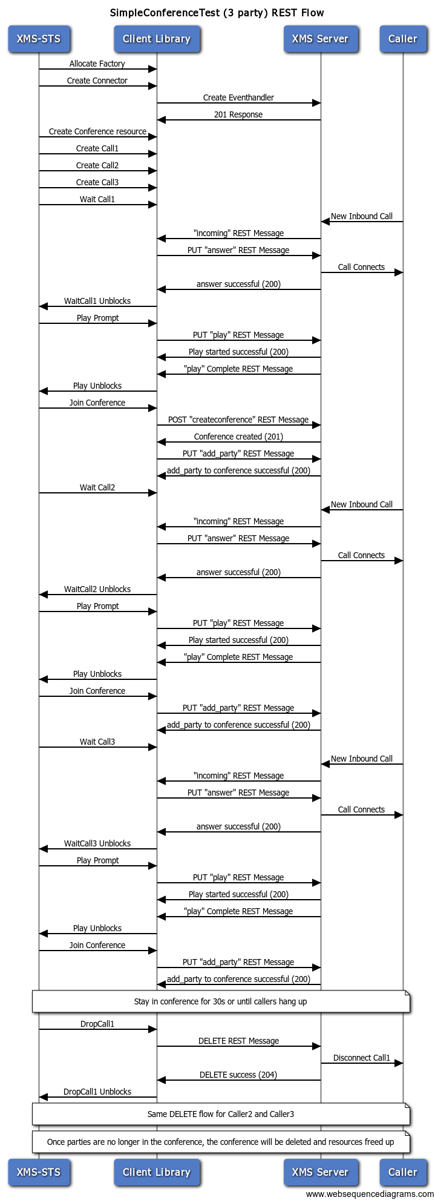

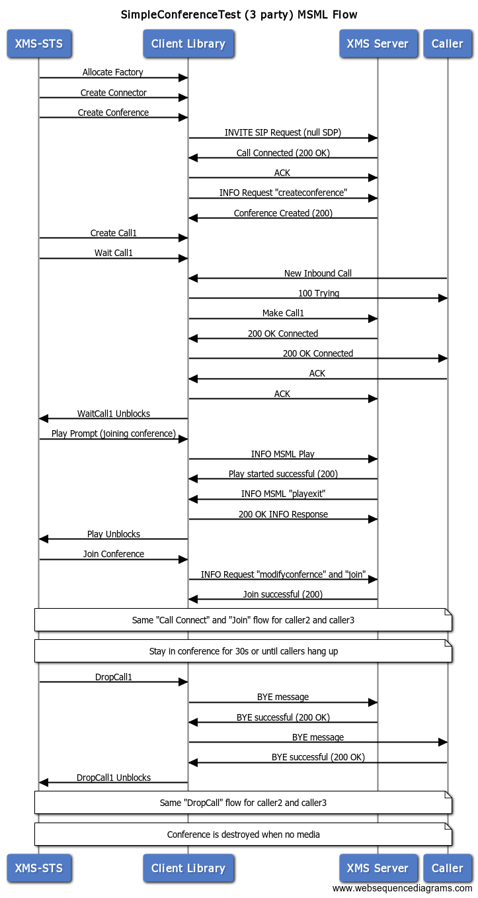

**SimpleIVRTest**

Test related to digit detection.

Steps:

1. Client calls into app.
2. Prompt is played "Press 1 for Sales, Press 2 for services, Press 3 for CEO"
3. Based on user DTMF, play prompt "you've reached ____" (selection)"

*REST:*

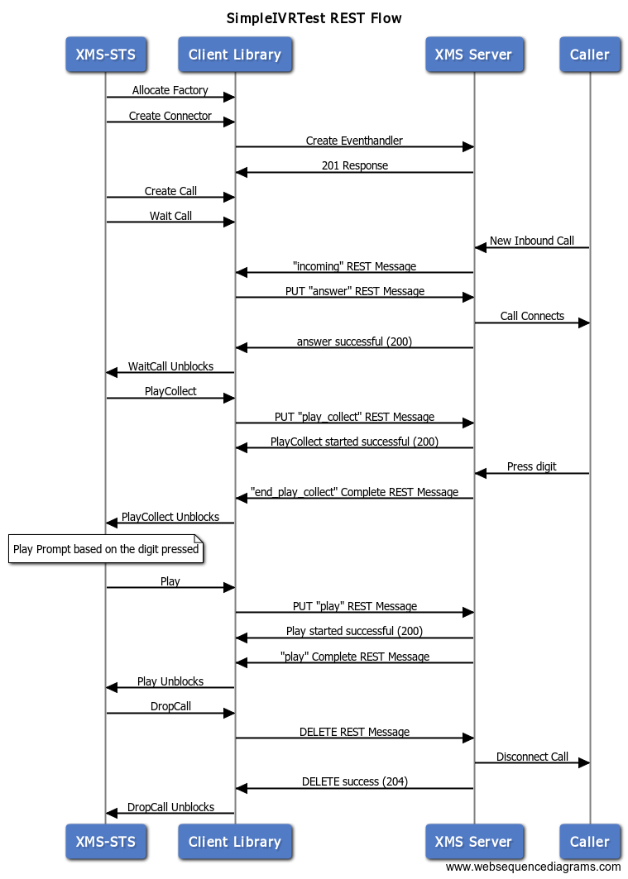

MSML:

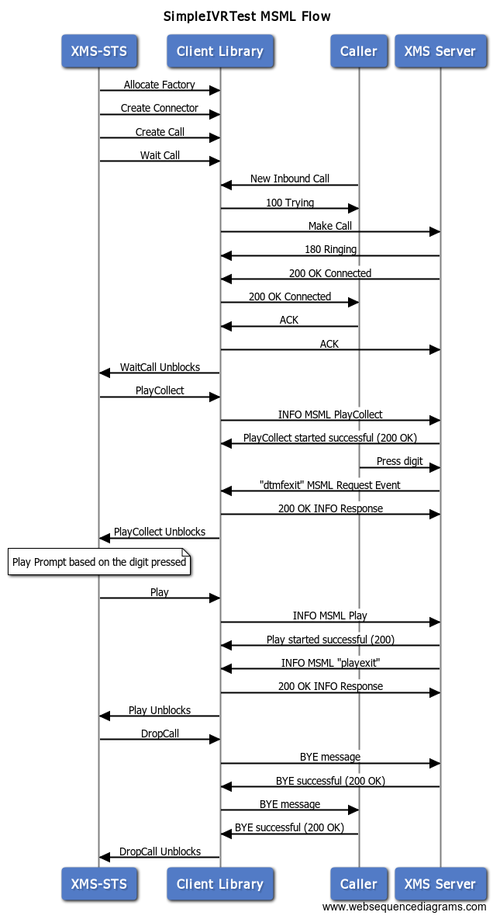

**Reporting**

Audit files are created at the end of each test case execution for references. These audit files are maintained in “auditFiles” folder under XMS-STS project.

An audit file consists of details of the program execution and is recorded as checkpoints. They also have information about the configuration settings, success/failure of each checkpoint, short description about the checkpoint, long description with REST events or MSML content and finally the status of the test (SUCCESS/FAILURE).

While the test is executing, each of these checkpoints are also displayed on the controller window under the “status” column.

ConnectTestAudit Sample

<?xml version="1.0" encoding="UTF-8"?>

<java version="1.8.0_40" class="java.beans.XMLDecoder">

<object class="com.dialogic.xms.smoke.test.Audit">

<void property="auditTestName">

<string>OutboundPlayTest</string>

</void>

<void property="checkpointCount">

<int>3</int>

</void>

<void property="configContents">

<object class="com.dialogic.xms.smoke.test.Config">

<void property="appID">

<string>app</string>

</void>

<void property="callType">

<string>Outbound</string>

</void>

<void property="channels">

<int>1</int>

</void>

<void property="count">

<int>1</int>

</void>

<void property="ipAddress">

<string>http://146.152.64.141:81/default/</string>

</void>

<void property="outboundAddress">

<string>sip:toto@10.20.120.20:5060</string>

</void>

<void property="playFileName">

<string>smoketest/success</string>

</void>

<void property="port">

<int>5070</int>

</void>

<void property="stim">

<string>Manual</string>

</void>

<void property="type">

<string>REST</string>

</void>

</object>

</void>

<void property="configFileName">

<string>config/ConnectTestConfig.xml</string>

</void>

<void property="numPass">

<int>2</int>

</void>

<void property="startTime">

<string>[10:49:22.826] </string>

</void>

<void property="testCheckpoints">

<object class="java.util.ArrayList">

<void method="add">

<object class="com.dialogic.xms.smoke.test.Checkpoint">

<void property="checkpointName">

<string>MakeCall</string>

</void>

<void property="checkpointStartTime">

<string>[10:49:23.450] </string>

</void>

<void property="checkpointStatus">

<string>SUCCESS</string>

</void>

<void property="longDesc">

<string>XMSRestEvt- ID=0befb42d-3cb2-41c2-acd5-c4f0692f6c3b Type=connected ResourceType=call event=&lt;xml-fragment type=&quot;connected&quot; resource_id=&quot;0befb42d-3cb2-41c2-acd5-c4f0692f6c3b&quot; resource_type=&quot;call&quot;&gt;&#13;

&lt;event_data name=&quot;call_id&quot; value=&quot;0befb42d-3cb2-41c2-acd5-c4f0692f6c3b&quot;/&gt;&#13;

&lt;event_data name=&quot;called_uri&quot; value=&quot;&amp;lt;sip:toto@10.20.120.20:5060&gt;;tag=Xia4S92&quot;/&gt;&#13;

&lt;event_data name=&quot;caller_uri&quot; value=&quot;&amp;lt;sip:146.152.64.141&gt;;tag=f0bce880-8d409892-13c4-50022-1639f-5af7ca0a-1639f&quot;/&gt;&#13;

&lt;event_data name=&quot;media&quot; value=&quot;audio&quot;/&gt;&#13;

&lt;event_data name=&quot;reason&quot; value=&quot;unknown&quot;/&gt;&#13;

&lt;event_data name=&quot;type&quot; value=&quot;CONNECTED&quot;/&gt;&#13;

&lt;/xml-fragment&gt;</string>

</void>

<void property="shortDesc">

<string>Making an outbound call</string>

</void>

</object>

</void>

<void method="add">

<object class="com.dialogic.xms.smoke.test.Checkpoint">

<void property="checkpointName">

<string>Play</string>

</void>

<void property="checkpointStartTime">

<string>[10:49:24.445] </string>

</void>

<void property="checkpointStatus">

<string>SUCCESS</string>

</void>

<void property="longDesc">

<string>XMSRestEvt- ID=0befb42d-3cb2-41c2-acd5-c4f0692f6c3b Type=end_play ResourceType=call event=&lt;xml-fragment type=&quot;end_play&quot; resource_id=&quot;0befb42d-3cb2-41c2-acd5-c4f0692f6c3b&quot; resource_type=&quot;call&quot;&gt;&#13;

&lt;event_data name=&quot;duration&quot; value=&quot;4470&quot;/&gt;&#13;

&lt;event_data name=&quot;id&quot; value=&quot;0befb42d-3cb2-41c2-acd5-c4f0692f6c3b&quot;/&gt;&#13;

&lt;event_data name=&quot;media_id&quot; value=&quot;a7974944-1781-4839-aa92-e92131a7df08&quot;/&gt;&#13;

&lt;event_data name=&quot;reason&quot; value=&quot;end&quot;/&gt;&#13;

&lt;event_data name=&quot;status&quot; value=&quot;0 No Error&quot;/&gt;&#13;

&lt;event_data name=&quot;transaction_id&quot; value=&quot;a7974944-1781-4839-aa92-e92131a7df08&quot;/&gt;&#13;

&lt;event_data name=&quot;type&quot; value=&quot;END_PLAY&quot;/&gt;&#13;

&lt;/xml-fragment&gt;</string>

</void>

<void property="shortDesc">

<string>Playing</string>

</void>

</object>

</void>

<void method="add">

<object class="com.dialogic.xms.smoke.test.Checkpoint">

<void property="checkpointName">

<string>DropCall</string>

</void>

<void property="checkpointStartTime">

<string>[10:49:39.137] </string>

</void>

<void property="checkpointStatus">

<string>SUCCESS</string>

</void>

<void property="longDesc">

<string>XMSRestEvt- ID=0befb42d-3cb2-41c2-acd5-c4f0692f6c3b Type=end_play ResourceType=call event=&lt;xml-fragment type=&quot;end_play&quot; resource_id=&quot;0befb42d-3cb2-41c2-acd5-c4f0692f6c3b&quot; resource_type=&quot;call&quot;&gt;&#13;

&lt;event_data name=&quot;duration&quot; value=&quot;4470&quot;/&gt;&#13;

&lt;event_data name=&quot;id&quot; value=&quot;0befb42d-3cb2-41c2-acd5-c4f0692f6c3b&quot;/&gt;&#13;

&lt;event_data name=&quot;media_id&quot; value=&quot;a7974944-1781-4839-aa92-e92131a7df08&quot;/&gt;&#13;

&lt;event_data name=&quot;reason&quot; value=&quot;end&quot;/&gt;&#13;

&lt;event_data name=&quot;status&quot; value=&quot;0 No Error&quot;/&gt;&#13;

&lt;event_data name=&quot;transaction_id&quot; value=&quot;a7974944-1781-4839-aa92-e92131a7df08&quot;/&gt;&#13;

&lt;event_data name=&quot;type&quot; value=&quot;END_PLAY&quot;/&gt;&#13;

&lt;/xml-fragment&gt;</string>

</void>

<void property="shortDesc">

<string>Drop call</string>

</void>

</object>

</void>

</object>

</void>

<void property="testStatus">

<string>SUCCESS</string>

</void>

</object>

</java>

**Sample XML document for configuration setting**

Config files are also present in the “config” folder under XMS-STS project.

ConnectTest Sample

<xmsconfig>

<techtype>REST</techtype>

<baseurl>http://146.152.64.141:81/default/</baseurl>

<appid>app</appid>

<port>5070</port>

<count>1</count>

<channels>1</channels>

<configFile>config/ConnectTestConfig.xml</configFile>

<playFile>smoketest/success</playFile>

<video>False</video>

<callType>Outbound</callType>

<outboundAddress>sip:toto@10.20.120.20:5060</outboundAddress>

<stim>Manual</stim>

</xmsconfig>